‘Down in the
Understanding the World
- I can draw a simple map.
- I can talk about the life cycle of a butterfly.
- I can explore the natural world around me. E.g. minibeasts
- I can talk about the similarities and differences to Christianity and to other religions.
- I can talk about how I have changed since I was a baby.
- I can talk about members of my immediate family.
- I know what seeds need to grow.
- I can recognise some similarities and differences between life in my country and life in Africa.
Expressive Arts and Design
- I can explore artists Van Gogh and Matisse and create my own interpretations.
- I can develop a storyline into my play.
- I can sing simple songs and poems in a group or on my own.
- I can match the pitch and follow a melody.
- I can explore and engage in music making.
- I can understand the ways to play percussion instruments
- I can play a simple/steady beat and change tempo.
Communication, language and Literacy
- I can describe the main events of a story.
- I can engage with a range of texts during story time.
- I can articulate my ideas in well-formed sentences.
- I can listen carefully during class discussions.
- I can recognise some common exception words. E.g. the my
- I can read simple sentences and captions independently.
- I can blend to read words with 3/4/5 sounds. E.g. cat, trap. strop
- I can recognise the Special Friend Set 2 sounds and blend them to read simple words. E.g. s-n-ow
- I can write a sentence that can be read by others.
- I can use finger spaces, a capital letter and full stop when I’m writing a sentence.

Personal, Social and Emotional Development
- I can follow the school and class rules.
- I can seek out new activities and challenges independently.
- I can solve small conflicts through speaking to my friends.
- I can consider the feelings of others.
- I can persevere when something is challenging.
- I can talk about the different factors that support me to have a good healthy wellbeing. E.g. sleep, screen time, brushing my teeth

Garden’
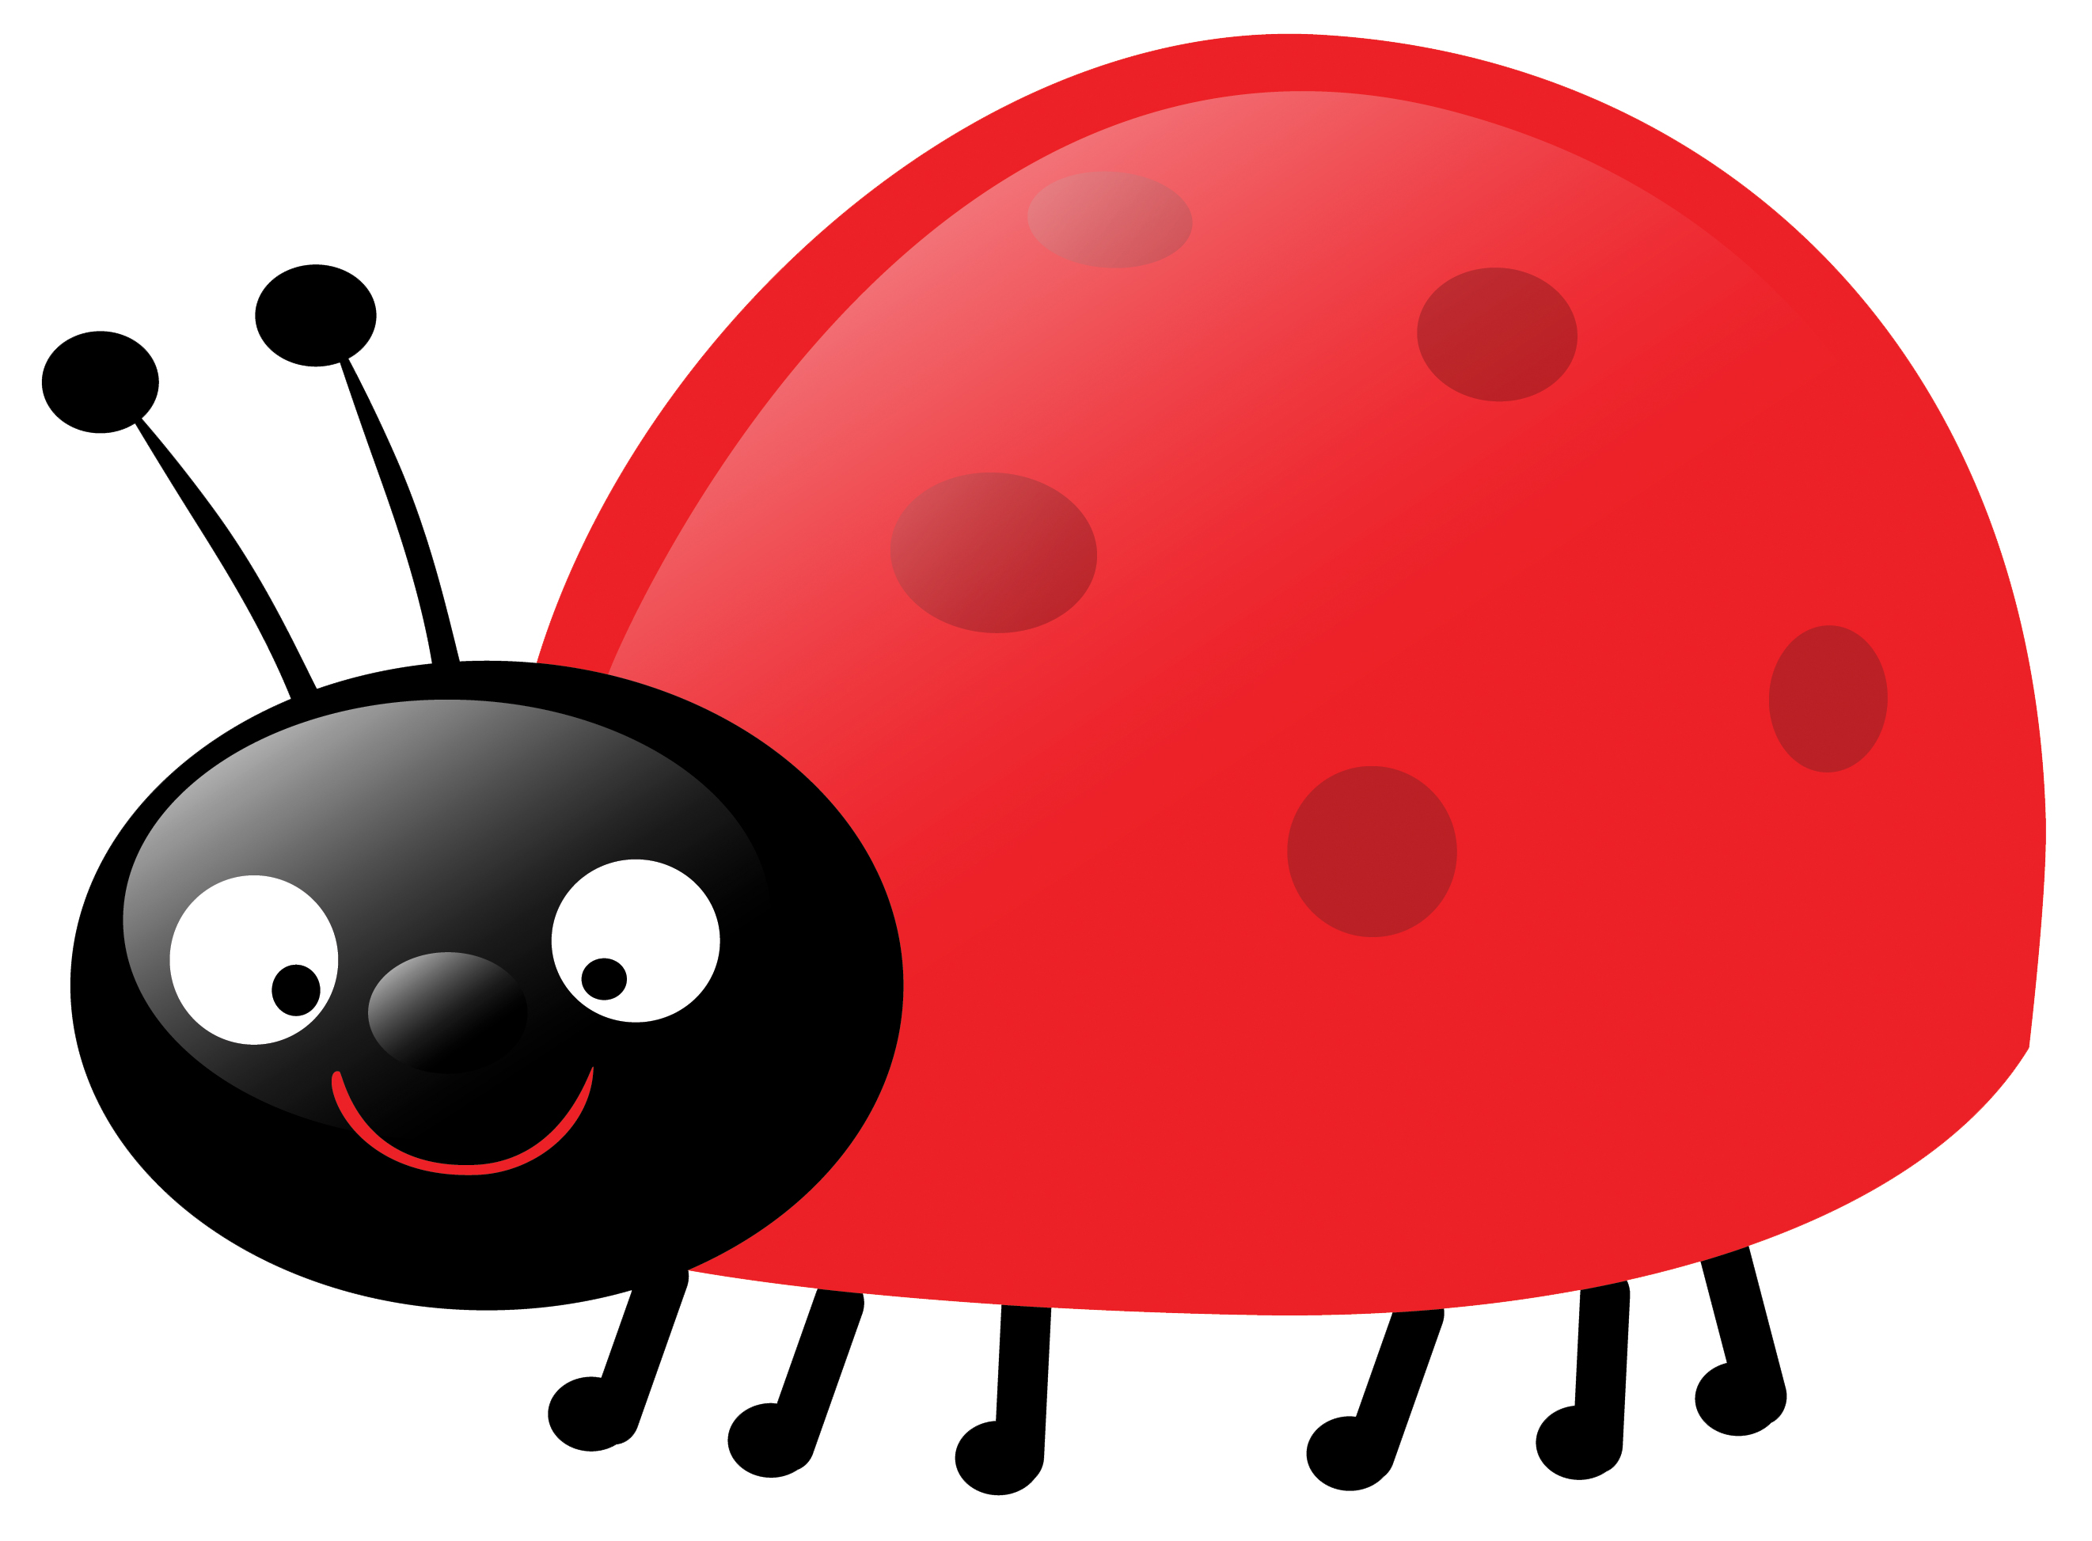
Mathematics
- I can count 1:1, using one number name for each object counted.
- I can subitise (recognise quantities without counting) up to 5.
- I can say one more/one less for a number up to 10.
- I can recognise, write and order numbers up to 20.
- I can name and describe 3D shapes.
- I can explore the composition of numbers to 10.
- I can automatically recall number bonds for numbers to 10.
- I can use measurement language to compare-length, capacity and weight.

Physical Development
- I can form most of my letters correctly, making sure I start at the correct place.
- I can develop control and coordination when handling equipment like balls and bats.
- I can catch and strike a ball with growing accuracy.
- I can demonstrate strength, balance and coordination when playing.

