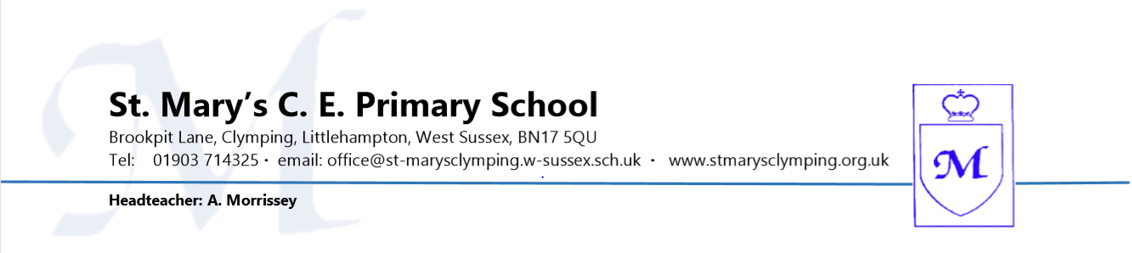
REQUEST FOR ABSENCE IN SCHOOL TIME
- Pupils attend school for 190 days each academic year
- There are 175 additional days for holidays and other activities
- 80% attendance represents 1 day off a week 90% attendance represents 1 day off a fortnight
HOW TO USE THIS FORM
- Use this form for all absences other than sickness
- Use a separate form for each child and each absence
- Return the form to school in advance of the requested absence
- Any requests for HOLIDAY absence must be accompanied by a letter addressed to the Chair of Governors explaining the ‘exceptional circumstances’ request being made
- If the request for holiday absence is not authorised and if the child is then absent on the specified dates, the absence will be recorded as unauthorised and the parents may receive a Fixed Penalty Notice
PARENT/CARER TO COMPLETE THIS SECTION
Parent/Carer’s Name:

Address:

Name of Child: | Year Group:
Is this the first request for absence this academic year? YES / NO
Inclusive dates of absence requested:  Start date: End date: | Number of school days requested:
Reason for absence request:

Does your child have school dinners? YES / NO
If YES and you pay for your child’s lunch you should inform Chartwells of the dates of the absence. Depending on how much notice you give, you could still be charged for the meal(s).
Phone: 01243 836130 or 0845 603 7998 Email: 73041@compass-group.co.uk

Signature of Parent/Carer: | Date Signed:
School Office to Complete this Section
Current Attendance Percentage: | Teacher Informed: YES / NO
Total number of sessions missed for holiday: | Date reply sent to parent/carer:
Other absence reasons:
Number of sessions missed for illness: | Signature of Administrator: Date:  Signature of Headteacher: Date:
Number of sessions missed for other absences:
Attendance Register Code for this absence:
Absence: AUTHORISED or UNAUTHORISED

PLEASE RETURN COMPLETED FORM TO THE SCHOOL OFFICE

